Report Partitioning

Aliaksandr_Labayeu

## **Step 1:** Creating tablespaces and privileges to USER

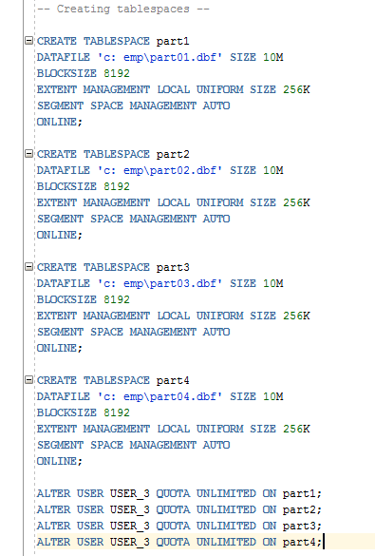

## **Step 2:** Creating Hash and Range partitions

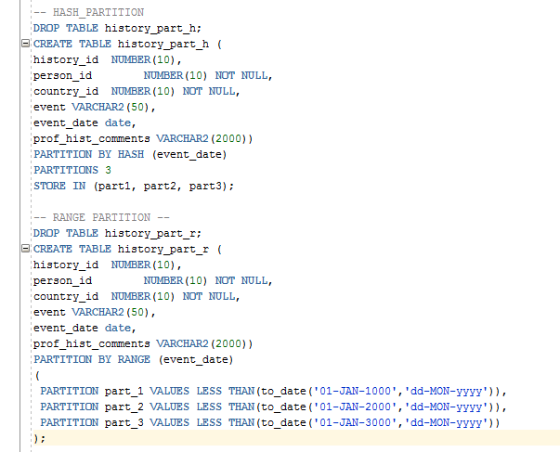

## **Step 3:** INSERTING random values:

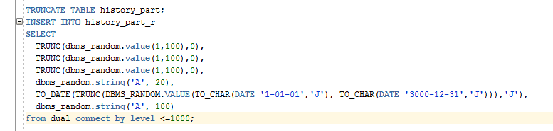

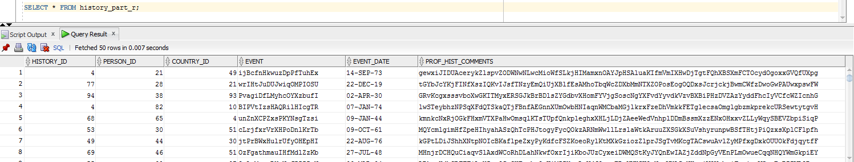

Making clear that table has partitions:

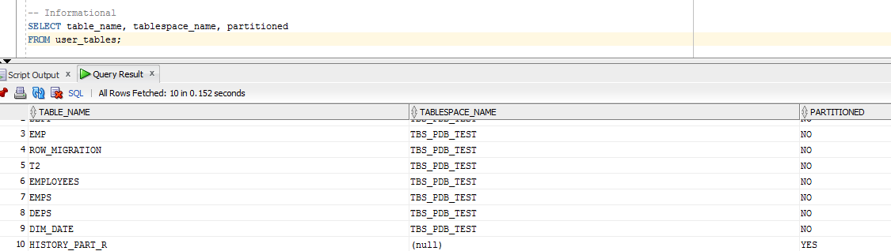

## **Step 4:** Gathering stats and getting information about blocks and rows in every partition:

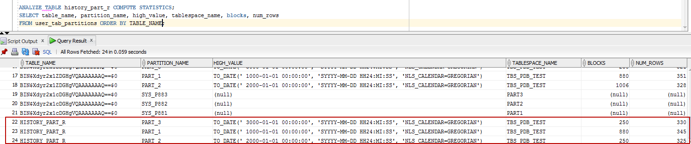

## **Step 5**: Partitioning

**It should be mentioned that screenshots go one after the other and provide ability to make comparison between them**

1. Dropping partition

Dropping partitions allowed to hash-partitioned table or for hash subpartitions of a composite-partitioned table (use Coalesce) and it just drops existing partition:

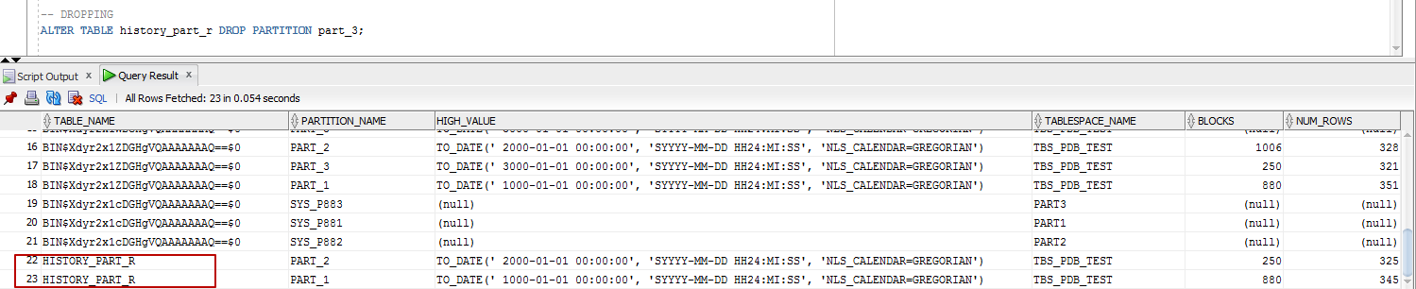

1. Adding partition

Adding partition just creates new partition in table

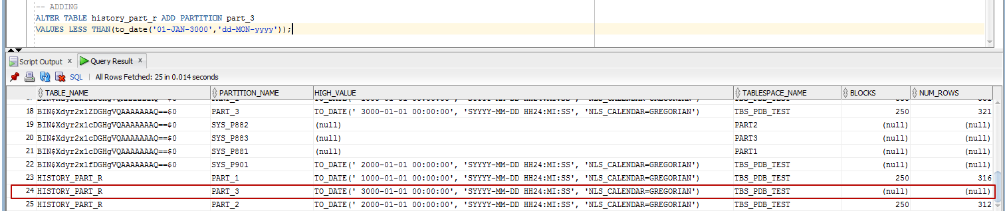

1. Merging partitions

Merge partitioning merges 2 or more partitions into one.

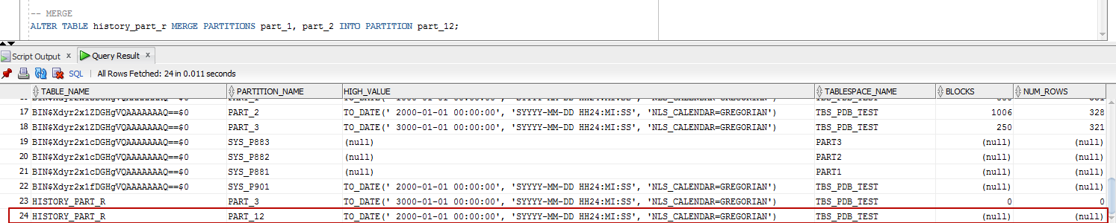

It should be mentioned that only adjacent partitions can be merged.

1. Splitting Partitions

Splitting partitioning makes the reverse result of merge – split the appropriate partitions into some (we can define how many) partitions.

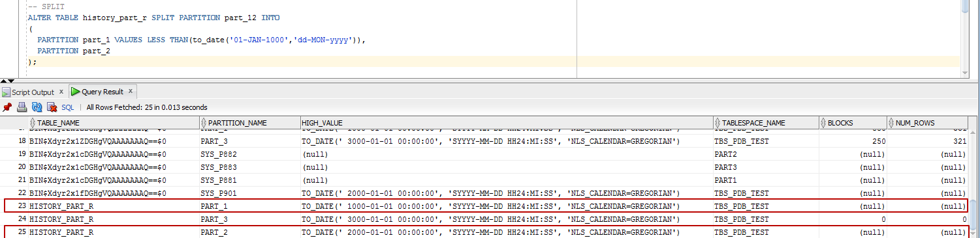

Other examples will be executed on the table with the same structure, but with hash partitioning, because Coalescing and Moving operations can be made only with Hash partitions. Truncate partition will show the row deleting from the partition (so as not to insert rows in the table with range partitioning again and gather statistics because everything has gone due to partition operations).

After creating Hash partitioned table we get these results:

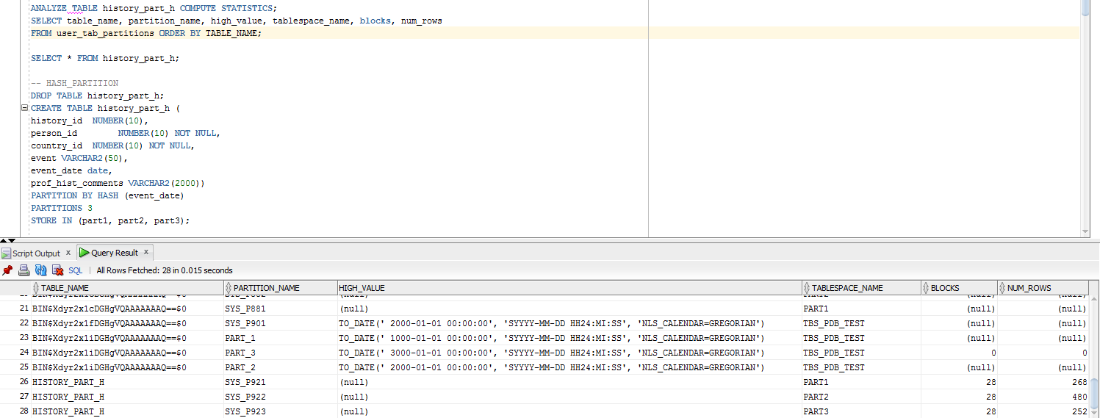

As we can see, hash partitioning uses extremely less number of blocks compared to range partitioning, where the results in sum gave the amount of more than 1300 blocks usage.

1. Coalescing Partitions

Coalescing partitioning is used to reduce the number of partitions automatically or manually (if we point the number in PARTITIOIN)

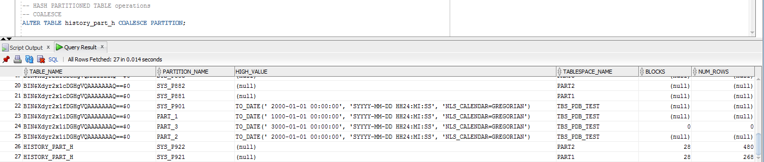

1. Moving Partitions

Moving partitions allows to manually choose the tablespace we want to use for this or that partition.

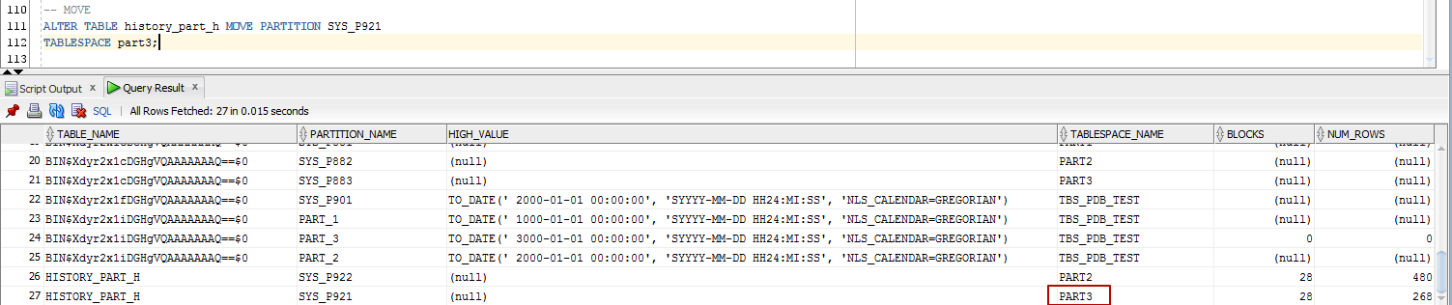

We also have to update indexes (using “UPDATE INDEXES” at the end of the statement) if we have them (in my example I have no indexes or PKs) and if we use global index (local index does not require to be updated).

1. Truncating Partitions

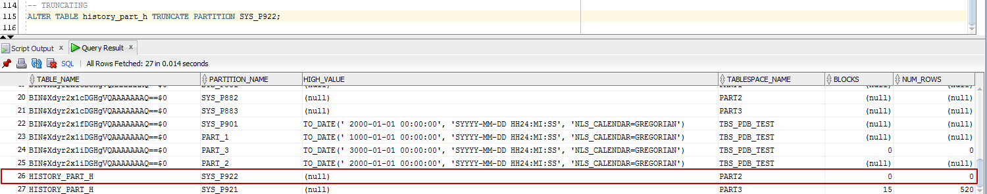

After applying truncate action we should gather statistics and then we got 0 rows in partitions so as we’ve already deleted them.